REICE
Revista Electrónica de Investigación en Ciencias Económicas
Abriendo Camino al Conocimiento
Facultad de Ciencias Económicas, UNAN-Managua

Vol. 10, No. 20, julio - diciembre 2022 REICE ISSN: 2308-782X
http://revistacienciaseconomicas.unan.edu.ni/index.php/REICE
revistacienciaseconomicas@gmail.com

Interrelation of Indicators of Economic and Innovative Growth and Their Impact on Sustainable Development

Interrelación de Indicadores de Crecimiento Económico e Innovador y su Impacto en el Desarrollo Sostenible

Fecha recepción: noviembre 02 del 2022
Fecha aceptación: noviembre 17 del 2022
DOI: 10.5377/reice.v10i20.16032

Natalia Sadovnikova
Plekhanov Russian University of Economics, Russia.
Email: Sadovnikova.NA@rea.ru
ORCID: https://orcid.org/0000-0001-7630-2222
Kirill Kuznetsov
Plekhanov Russian University of Economics, Russia.
Email: kir.v.kuznetsov@bk.ru
ORCID: https://orcid.org/0000-0001-7348-8199

Derechos de autor 2021 REICE: Revista Electrónica de Investigación en Ciencias Económicas. Esta obra está bajo licencia internacional Creative Commons Reconocimiento-NoComercial-CompartirIgual 4.0.Copyright (c) Revista Electrónica de Investigación en Ciencias Económicas de la Unan- Managua

Resumen

Los autores del artículo estudian la optimización de procesos de negocio en empresas manufactureras. Se estudió el concepto de procesos de negocio y sus funciones. Se eligieron como principales métodos la cognición, el análisis retrospectivo y documental, así como la síntesis, la generalización y la sistematización. Como resultado del estudio, los autores identificaron las principales etapas y aspectos teóricos de los procesos de negocios en empresas manufactureras, identificaron posibles alternativas a la elección estratégica e indicadores de la efectividad del proyecto de inversión, y propusieron modelos de procesos de negocios para las actividades de la empresa.
Palabras clave: Modelos Innovadores; Inversiones; Indicadores de desempeño; Empresas de manufactura.

Abstract
The authors of the article study the optimization of business processes in manufacturing companies. The concept of business processes and their functions was studied. The main methods were chosen cognition, retrospective and documentary analysis, as well as synthesis, generalization and systematization. As a result of the study, the authors identified the main stages and theoretical aspects of business processes in manufacturing companies, identified possible alternatives to the strategic choice and indicators of the effectiveness of the investment project, and proposed business process models for the company's activities.

Keywords: Innovative Models; Investments; Performance indicators; Manufacturing companies.

Introduction

The Sustainable Development Goals are aimed at improving the standard of living of the population, reducing inequality, economic growth, and preserving natural resources. At the same time, it can be said that achieving the Sustainable Development Goals in the field of innovation and ecology is impossible without achieving the fundamental goals of sustainable development, which are necessary for survival. In many developing countries, there are still problems of high poverty of the population. Among the fundamental goals of sustainable development, SDG 1 – "Eradication of poverty" and SDG 2 – "Elimination of hunger" should be highlighted. We can say that these SDGs are fundamental and necessary for the physiological survival of a person. According to the theory of the American psychologist A. Maslow, these SDGs should be attributed to the physiological needs, without which higher needs cannot be realized. According to the theory of human capital, the economic development of the country and innovative growth is impossible without constant investment in education.
It should be noted that the achievement of the indicators of SDG 13 ("Combating climate change"), SDG 14 ("Conservation of marine ecosystems"), will be possible only due to the achievement of the indicators of SDG 8 and SDG 9, which in turn can be achieved only after the indicators of SDG 1, SDG 2 and SDG 3. For monitoring Achieving the Sustainable Development Goals requires high-quality data. The international analysis of indicators is complicated by the lack of data on some indicators for a number of countries. It should be noted the different time periods of the formation of the SDGs. For example, the indicator "proportion of the population with an income below $1.9 per day" included in SDG 1 is presented for 2015-2021, and the indicator "spread of malnutrition" included in SDG 2 is presented only for 2015-2018. The lack of data for some years may be explained by the peculiarities of the work of statistical agencies in different countries. It can be assumed that the indicator "prevalence of malnutrition" is formed on the basis of household surveys.

Materials and Methods

Sustainable development theorists strive to prioritize and integrate social, environmental and economic models into solving human problems in such a way that it constantly benefits people (Hussain et al., 2014; UNSD, 2018). Part of the research in the field of SDGs is devoted to the problems of the relationship between SDGs and solving environmental problems (Adrangi and Kerr, 2022). Other researchers have studied the relationship of the UN SDGs with migration (Prada, 2020). Prada was able to substantiate the relationship between migration and the SDGs: migration can influence the achievement of sustainable development, and, conversely, the achievement of these goals also contributes to migration to the EU. The Coscieme study concludes that the focus on GDP growth leads to the inability to achieve the SDGs as a whole (Coscieme et al., 2020). Most of the cross-country comparisons on the SDGs are focused on European countries. Russia is not fully represented in such comparisons. In this connection, the purpose of the study is to determine the level of development of the Russian Federation according to the indicators of the Sustainable Development Goals, to identify countries similar in level of development, the relationship between the indicators of the Sustainable Development Goals.
Data sources for the study are data from the Federal State Statistics Service (Rosstat) (n.d.), data from the Sustainable Development Report, the Voluntary National Review of the Sustainable Development Goals (United Nations, n.d., 2022). Data processing was carried out in the application software packages "R" and IBM "SPSS".
In order to determine the closeness of the link between the Sustainable Development Goals, one indicator was selected from each Goal for 2019. It is important to note that for some SDG indicators, data are not provided for all countries, and for some there are no data for the period under review. For example, among the presented data for 2019 on SDG 1 among 193 countries, there are no values for indicators in 32 countries (16.6%) among the countries under consideration. Thus, the selection of indicators for each SDG was carried out taking into account the proportion of missing values by country.
Indicators from 9 Sustainable Development Goals were selected for the correlation analysis:
- Percentage of the population with an income below $1.9, (%) (SDG 1);
- Neonatal mortality rate (per 1,000 live births) (SDG 3);
- Percentage of women in the National Parliament (%) (SDG 5);
- Internet-using population (%) (SDG 9);
- Average annual concentration of solid particles with a diameter of less than 2.5 microns (mcg/m3) (SDG 11);
- CO₂ emissions from fossil fuel combustion and cement production (tCO2 per capita) (SDG 13);
- Survival index of species from the Red Book (0-1), (SDG 15).
Lack of SDG indicators 2, 4, 6, 7, 8, 10, 12, 14, 16, 17 it is caused by a significant number of country passes. The largest share of data omissions is noted for SDG 4 indicators – 63.2% among all the countries represented. Thus, in order to determine the greatest closeness between indicators, indicators with a large number of data gaps were excluded. After excluding countries where at least one indicator is missing, an analysis was conducted for 160 countries on 7 SDGs. Statistical characteristics of the indicators are given in Table.1.

Table 1: Statistical characteristics by components of the Sustainable Development Goals, 2019
Indicator | mean | minimum | maximum | standard deviation
Percentage of the population with an income below $1.9, (%) (SDG 1) | 12,70 | 0,00 | 83,13 | 20,42
Neonatal mortality rate (per 1,000 live births) (SDG 3) | 12,41 | 0,80 | 42,80 | 10,76
Proportion of women in the national Parliament (%) (SDG 5) | 23,96 | 0,00 | 61,25 | 11,74
Population using the Internet, (%) (SDG 9) | 56,56 | 2,00 | 99,70 | 29,12
Average annual concentration of solid particles with diameters less than 2.5 microns (mcg/m3) (SDG 11) | 28,36 | 5,54 | 106,12 | 20,80
CO₂ emissions from fossil fuel combustion and cement production (tCO2 per capita) (SDG 13) | 4,77 | 0,03 | 38,61 | 5,88
Survival index of species from the Red Book (0-1), (SDG 15) | 0,86 | 0,41 | 0,99 | 0,10
Source: authors' calculations based on Rosstat data

Due to the different units of measurement of indicators, the indicators were normalized according to the formula:
$$z_{ij}=\frac{x_{ij}-{\overset{̿}{x}}_{j}}{s_{j}}$$
zij – normalized value of attribute j for district i;
xij – the value of attribute j for district i;
$\overset{̿}{x_{j}}$- the average value of the attribute j;
Sj – the standard deviation of the attribute j.
Based on the selected indicators, the Ward method conducted clustering of countries for two periods 2015 and 2019.

Resultados and Discussion
There is a certain synergistic effect between the individual SDGs. The progress and achievement of the SDGs in the future will depend on whether synergies and trade-offs can be identified and eliminated. Thus, poverty, high income differentiation by income level can restrain technological development, hinder the creation of high-tech jobs. And vice versa, they may, if not hinder the development of poverty. Statistical characteristics of the components of the Sustainable Development Goals for 2019 are presented in Table 2.

Table 2: Correlation matrix between indicators of the Sustainable Development Goals
 | Indicator 1 | Indicator 3 | Indicator 5 | Indicator 9 | Indicator 11 | Indicator 13 | Indicator 15
SDG Indicator 1 | 1,000 | 0,708** | -0,133 | -0,741** | 0,348** | -0,420** | 0,074
SDG Indicator 3 | 0,708** | 1,000 | -0,264** | -0,836** | 0,555** | -0,533** | 0,033
SDG Indicator 5 | -0,133 | -0,264** | 1,000 | 0,318** | -0,153 | 0,229** | 0,113
SDG Indicator 9 | -0,741** | -0,836** | 0,318** | 1,000 | -0,491** | 0,622** | 0,099
SDG Indicator 11 | 0,348** | 0,555** | -0,153 | -0,491** | 1,000 | -0,296** | 0,077
SDG Indicator 13 | -0,420** | -0,533** | 0,229** | 0,622** | -0,296** | 1,000 | 0,132
SDG Indicator 15 | 0,074 | 0,033 | 0,113 | 0,099 | 0,077 | 0,132 | 1
(**) significance level 0.01
(*) significance level 0.05

There is a significant (at the significance level a=0.01) high positive relationship between the indicator "Proportion of the population with an income below $1.9" (SDG 1) and the indicators for SDG 3 – the neonatal mortality rate. It can be said that the infant mortality rate is closely related to the level of poverty in the country: the higher the poverty in the country, the higher the infant mortality rate. We can say that this dependence is mainly characteristic of the countries of the African continent, which are characterized by high infant mortality and low life expectancy. We can say that these countries have not yet passed the stage of the second demographic transition: the transition from high mortality and high fertility to low mortality and low fertility. Of course, the reduction of mortality cannot be achieved without the development of the health system.
A significant negative relationship is observed between the indicators "The proportion of the population with an income below $1.9" (SDG 1) and "The population using the Internet" (SDG 9). The higher the level of poverty in the country, the lower the proportion of the population with access to the Internet. It can be said that getting access to the Internet requires significant household expenses for the purchase of equipment, as well as payment for access.
A negative correlation of average strength is also observed between the indicators "Share of the population with an income below $1.9" (SDG 1) and "CO₂ emissions from burning fossil fuels and cement production (per capita)" (SDG 13). It can be assumed that for countries with high poverty rates, the level of co₂ emissions per person will be lower due to technological backwardness: lack of modern electrical appliances, low mobility, lack of money for a car, lack of need for a central heating system (for example, due to climatic features).
A high correlation is observed between the indicator "neonatal mortality rate" (SDG 3) and "The population using the Internet" (SDG 9). This can also be explained by the level of development of States. A high mortality rate may be one of the indicators of a low level of development of the state. In the future, correlation matrices will be constructed for the relationships under consideration. There is a correlation between the average strength of the indicators "The population using the Internet" (SDG 9) and co₂ emissions from the burning of fossil fuels and cement production (CO2 per capita) (SDG 13). This relationship can be explained as follows: countries where the population has high rates of access to the Internet can be characterized by a large number of electrical appliances that consume a significant amount of electricity.
The problem of combating poverty is one of the most important in the world. Currently, the poverty criterion is defined as $1.9 per person per day. At the same time, the target values for the criterion of the poverty level are considered as 3.2 US dollars per person. According to data for 2019, the largest share of the population with incomes below $1.9 is observed in South Sudan (83.13%), Central African Republic (78.24%), Burundi (78.06). These countries are also characterized by high rates of neonatal mortality. The number of deaths per 1,000 births in South Sudan is 38.3, in the Central African Republic 39.7, in Burundi - 21. It should be noted that in the countries under consideration, the share of the population with incomes below $3.2 per person per day is more than 90%.
It should be noted that Russia has one of the lowest rates of the share of the population living on less than $1.9 per day (0.01%). This indicator is comparable to the values of Turkey, New Zealand, Kazakhstan. Similar values for this indicator are observed in some countries of the former USSR: Estonia – 0.03%, Belarus – 0.04%, Moldova – 0.05%, Ukraine – 0.06%, Slovenia – 0.08%. At the same time, the share of the population whose consumption level is less than 3.2 US dollars per day is 0.1% in Russia. This value is comparable to the values of Finland and Switzerland. When comparing countries with the neonatal mortality indicator (SDG 3), it should be noted that Russia has no significant differences from countries with similar indicators for the previously considered indicators of SDG 1. The relationship between the indicator "proportion of the population with an income below $1.9" (SDG 1) and "neonatal mortality rate" (SDG 3) is shown in Figure 1.

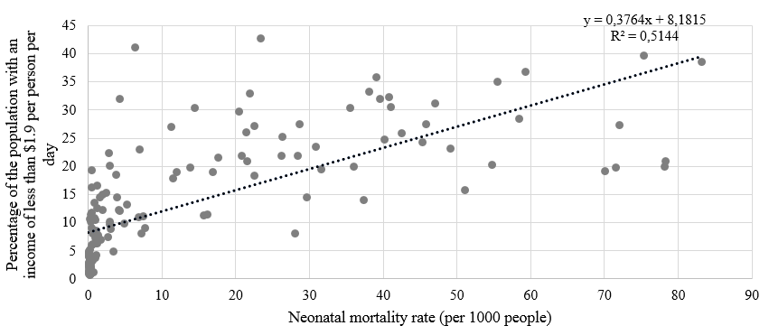
Figure 1: Correlation diagram between neonatal mortality rates (per 1,000 people) and the proportion of the population with incomes of less than $3.2 per day, 2019

As it was noted earlier, a high proportion of the population with low incomes can restrain the innovative growth of the economy. There is a strong negative relationship between the indicators "the share of the population with incomes below $1.9 per person per day" (SDG 1) and "the population using the Internet". Among the countries with the largest share of the population with access to the Internet are the United Arab Emirates (99.15%), Iceland (99.0%), Denmark (98.0%). At the same time, these countries are characterized by one of the lowest values according to the indicator of the share of the population with incomes less than $ 1.9: UAE – 0.22%, Iceland – 0.1%, Denmark – 0.17%.
Russia is characterized by relatively high values according to the indicator "the population using the Internet", and amounted to 82.6% in 2019. This value is comparable with some countries of the former USSR (Kazakhstan - 81.9%, Belarus – 82.8%), as well as some European countries (France – 83.3%, Poland – 84.5%). The correlation diagram between the indicators of the share of the population with monetary incomes of less than $ 1.9 and the share of the population with access to the Internet is shown in Figure 2.

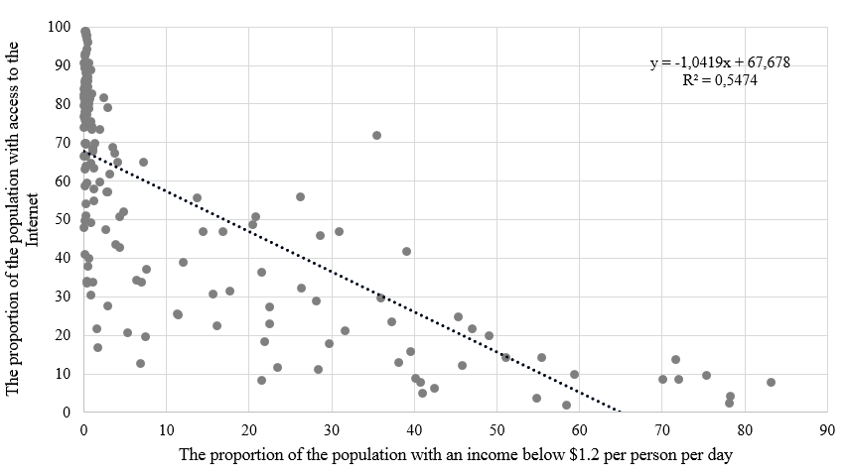
Figure 2: Correlation matrix between indicators of the share of the population with incomes less than $1.9 per person per day and the share of the population with access to the Internet, 2019

We can say that the border of the poverty level is very conditional. It can be said that in households living below the poverty line, spending on food will prevail. According to Engel's second law, the share of food expenses will increase with the growth of the number of household members. At the same time, in the work of Deaton and Paxson, an inverse relationship is noted: with an increase in the number of family members in the household, the average per capita expenditure on food will decrease. The need to calculate the poverty level boundary depending on the characteristics of the household is also caused by the effect of the scale of benefits of shared consumption. For example, the number of household appliances in a household of 1 person, as a rule, will be the same as in a household of two people. Thus, the monetary resources saved due to the scale effect of the household can be used to increase consumption.
On the basis of data from Surveys of household budgets of Rosstat for 2020, an assessment of the costs of the scale effect on food was carried out, depending on the size of the household and the area of residence. In carrying out this assessment, the costs of food, eating out and alcohol were taken into account.
On average, the level of spending on food for households in urban areas is higher than in rural areas (Figure 3). The lower level of spending on food in rural areas can be explained by the presence of a personal subsidiary farm, as well as the underdevelopment of the catering services sector outside the home. Calculations of the average per capita expenditure on food show that with an increase in the number of household members in the family, the level of average per capita expenditure on food decreases.

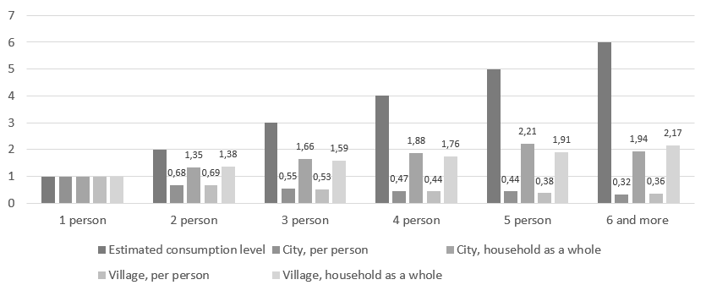
Figure 3: The level of household spending on food, depending on the number of family members in the household and the area of residence, 2020

Thus, when determining the poverty level, it is necessary to take into account not only the proportion of the poor population directly, but also the characteristics of the household: the number of family members, the infant mortality rate, the availability of Internet access that allows you to work remotely.
Based on the identified factors using the Ward method, the authors formed 4 clusters for two periods – 2015 and 2019 (Table 3 and Table 4).

Table 3: Characteristics of clusters in 2015 and 2019
Indicators | 2015 |  |  |  | 2019
 | 1 cluster | 2 cluster | 3 cluster | 4 cluster | 1 cluster | 2 cluster | 3 cluster | 4 cluster
The share of the population with incomes below $1.9. | 0,58 | 3,81 | 19,15 | 58,0 | 1,32 | 0,38 | 17,83 | 55,90
The share of the population with incomes below $3.2. | 1,52 | 12,29 | 43,82 | 80,7 | 8,26 | 0,96 | 39,93 | 78,80
Life expectancy, years | 78,61 | 73,64 | 65,61 | 60,6 | 75,24 | 79,16 | 66,67 | 62,45
Mortality rate up to 1 year | 3,95 | 11,10 | 24,42 | 29,9 | 9,31 | 3,64 | 22,14 | 27,95
The proportion of the population using the Internet network | 77,43 | 47,63 | 19,11 | 10,3 | 61,86 | 84,60 | 24,95 | 11,98
Subscriptions for mobile broadband access (per 100 people of the population) | 79,03 | 48,55 | 22,68 | 12,7 | 75,95 | 104,00 | 26,53 | 23,49

Table 4: Distribution of countries by clusters
2015 year |  |  | 2019 year
1 cluster
Albania, United Arab Emirates, Australia, Austria, Azerbaijan, Belgium, Belarus, Barbados, Canada, Switzerland, Chile, Costa Rica, Cyprus, Czech Republic, Germany, Denmark, Spain, Estonia, Finland, France, United Kingdom, Greece, Croatia, Hungary, Ireland, Iceland, Israel, Italy, Jordan, Japan, Kazakhstan, Korea, Rep., Lebanon, Lithuania, Luxembourg, Latvia, Moldova, North Macedonia, Malta, Montenegro, Malaysia, Netherlands, Norway, Poland, Portugal, Russian Federation, Singapore, Serbia, Slovak Republic, Slovenia, Sweden, Trinidad and Tobago, Uruguay, United States, Venezuela, RB |  | 55 |  | Albania, Armenia, Bulgaria, Bosnia and Herzegovina, Brazil, Bhutan, China, Colombia, Cabo Verde, Algeria, Ecuador, Egypt, Arab Rep., Gabon, Georgia, Indonesia, Iran, Islamic Rep., Iraq, Jamaica, Jordan, Maldives, Mexico, Mongolia, Mauritius, Panama, Paraguay, Tunisia, Uzbekistan, Vietnam |  | 29
2 cluster
Armenia, Bulgaria, Bosnia and Herzegovina, Belize, Bolivia, Brazil, Bhutan, Botswana, China, Colombia, Cabo Verde, Dominican Republic, Algeria, Ecuador, Egypt, Arab Rep., Gabon, Georgia, Iran, Islamic Rep., Iraq, Jamaica, Kyrgyz Republic, Morocco, Maldives, Mexico, Mauritius, Panama, Paraguay, Romania, Suriname, Thailand, Tonga, Tunisia, Turkey, Uzbekistan, Vietnam, South Africa |  | 36 |  | United Arab Emirates, Australia, Austria, Azerbaijan, Belgium, Belarus, Barbados, Canada, Switzerland, Chile, Costa Rica, Cyprus, Czech Republic, Germany, Denmark, Dominican Republic, Spain, Estonia, Finland, France, United Kingdom, Greece, Croatia, Hungary, Ireland, Israel, Italy, Japan, Kazakhstan, Korea, Rep., Lebanon, Lithuania, Luxembourg, Latvia, Morocco, Moldova, North Macedonia, Malta, Montenegro, Malaysia, Netherlands, Norway, Poland, Portugal, Romania, Russian Federation, Singapore, Serbia, Slovak Republic, Slovenia, Sweden, Trinidad and Tobago, Turkey, Uruguay, United States |  | 56
3 cluster
Bangladesh, Cote d'Ivoire, Cameroon, Comoros, Djibouti, Ghana, Guinea, Honduras, Haiti, Indonesia, India, Kenya, Cambodia, Lao PDR, Sri Lanka, Lesotho, Mongolia, Mauritania, Namibia, Nigeria, Nicaragua, Pakistan, Sudan, Senegal, Solomon Islands, Chad, Timor-Leste, Vanuatu, Sao Tome and Principe | 29 |  | Bangladesh, Belize, Bolivia, Botswana, Cote d'Ivoire, Cameroon, Comoros, Djibouti, Ghana, Guinea, Honduras, Haiti, India, Kenya, Kyrgyz Republic, Cambodia, Lao PDR, Sri Lanka, Lesotho, Mauritania, Namibia, Nigeria, Nicaragua, Pakistan, Sudan, Solomon Islands, Sao Tome and Principe, Suriname, Timor-Leste, Tonga, Venezuela, RB, South Africa, Vanuatu |  | 34
4 cluster
Angola, Burundi, Benin, Burkina Faso, Central African Republic, Congo, Dem. Rep. Guinea-Bissau, Mali, Mozambique, Malawi, Rwanda, Sierra Leone, South Sudan, Togo, Tanzania, Zambia | 16 |  | Angola, Burundi, Benin, Burkina Faso, Central African Republic, Congo, Dem. Rep., Guinea-Bissau, Mali, Mozambique, Malawi, Rwanda, Sierra Leone, South Sudan, Chad, Togo, Tanzania, Zambia |  | 17

The first cluster, the most prosperous, is characterized by a minimum proportion of the population with incomes below $ 3.2, the highest life expectancy (78.61 years), low infant mortality (3.95) and a high degree of coverage of the population with Internet access.
The second cluster includes fairly prosperous countries with fairly high indicators for all factor characteristics: the proportion of the population with incomes below $ 3.2 (12.29%), high life expectancy (73.64 years), low infant mortality (11.1) and a moderate degree of coverage of the population with Internet access.
It is important to note that in five years the boundaries of the cluster have undergone the most serious changes and this factor is associated with the massive transition of countries from the second cluster to the third. For example, the average infant mortality rate for the second cluster in 2015 was 11.1, and in 2019 it increased to 3.64, or another example: the average life expectancy (73.64 and 79.16, respectively).
The third cluster includes countries with a low standard of living, the growth of its poorest part (19.15% - the share of the population, with incomes below $ 1.9). The low level of medical care leads to a decrease in life expectancy (65.61 years), and the low availability of Internet access only exacerbates the problems.
The countries included in the fourth cluster can be described as the most disadvantaged. It is important to note that the countries forming this cluster in five years (2015-2019) we were never able to go beyond the cluster.

Conclusion

The results of the correlation analysis show the relationship of indicators of the Sustainable Development Goals. At the same time, we can say that without solving the problems of SDG 1, SDG 2 and SDG 3, countries cannot achieve the target values for goals aimed at sustainable economic growth, innovative development and ecosystem conservation.
In the Russian and foreign literature, it is noted that it is necessary to calculate the poverty level boundary taking into account the characteristics of households: when living together, there is a scale effect obtained through the joint consumption of common goods. Thus, the boundaries of the poverty level should be calculated not on average per person, but taking into account the characteristics of the household.

Acknowledgments
The article was prepared as part of a research work on the topic: "Methodological approaches of cross-country comparisons in assessing the implementation of Sustainable Development Goals based on the harmonization of various sources of information" funded from the funds of the Plekhanov Russian University of Economics (Order No. 866 of 06/28/2021).

Referencias
- Adrangi, B., Kerr, L. (2022). Sustainable development indicators and their relationship to GDP: Evidence from emerging economies. Sustainability, 14(2), 658. https://doi.org/10.3390/su14020658
- Coscieme, L., Mortensen, L.F., Anderson, S., Ward, J., Donohue, I., Sutton, P.C. (2020). Going beyond Gross Domestic Product as an indicator to bring coherence to the Sustainable Development Goals. Journal of Cleaner Production, 248. https://doi.org/10.1016/j.jclepro.2019.119232
- Federal State Statistics Service. (n.d.). Retrieved from: https://rosstat.gov.ru/
- Hussain, F., Chaudhry, M.N., Batool, S.A. (2014). Assessment of key parameters in municipal solid waste management: A prerequisite for sustainability. International Journal of Sustainable Development & World Ecology, 21(6), 519-525. https://doi.org/10.1080/13504509.2014.971452
- Prada, E.M..(2020). The relationship between Sustainable Development Goals and migration. An EU-28 perspective, Journal of Social and Economic Statistics, 9, 28-45.
- United Nations. (n.d.). Interlinked nature of the Sustainable Development Goals. Retrieved from: https://www.un.org/sustainabledevelopment/sustainable-development-goals/
- United Nations. (2022). Progress towards the Sustainable Development Goals Report of the Secretary-General. Supplementary information. Retrieved from: https://unstats.un.org/sdgs/files/report/2022/E_2022_55_Statistical_Annex_I_and_II.pdf
- UNSD. (2018). SDG indicators global database. Retrieved from: https://unstats.un.org/sdgs/indicators/database/

